AI-Powered Mathematical Chatbot with Handwritten Equation Recognition and Graph Visualization

Abstract
Artificial Intelligence (AI) and Natural Language Processing (NLP) have transformed the way humans interact with computers. Educational technology, particularly intelligent tutoring systems, has benefited significantly from these advancements. This project presents the design and implementation of an AI-Powered Mathematical Chatbot capable of solving mathematical problems, performing symbolic computations, recognizing handwritten equations from images, and visualizing mathematical functions through graph plotting.
The proposed system integrates Optical Character Recognition (OCR), Symbolic Mathematics, Natural Language Processing, and Data Visualization techniques into a single educational platform. Users can interact with the chatbot by entering mathematical expressions through text or by uploading handwritten equations. The system automatically interprets the input, processes mathematical operations, generates accurate solutions, and visualizes functions when required. The project demonstrates the practical application of AI technologies in mathematics education and provides a foundation for future intelligent learning systems.
Keywords: Artificial Intelligence, Natural Language Processing, Optical Character Recognition, Symbolic Mathematics, Chatbot, Graph Visualization, Machine Learning.

1.Introduction

1.1 Background
Mathematics is one of the most important disciplines in science and engineering. However, students often struggle with solving equations, understanding calculus concepts, and visualizing mathematical functions. Traditional calculators provide numerical answers but fail to explain underlying concepts.
Recent developments in AI have enabled the creation of intelligent educational assistants capable of understanding user queries and providing meaningful responses. Chatbots are among the most widely used AI applications due to their ability to simulate human-like interaction.
This project introduces an AI-based Mathematical Chatbot that combines Natural Language Processing, OCR, Symbolic Computation, and Graph Visualization to create an intelligent educational assistant.

1.2 Problem Statement
Existing calculators and basic mathematical tools suffer from several limitations:
- Lack of conversational interaction.
- Inability to understand handwritten equations.
- Limited support for symbolic mathematics.
- No integrated graph visualization.
- Absence of intelligent mathematical assistance.
The proposed chatbot addresses these limitations through an AI-driven architecture.

1.3 Objectives
The primary objectives of this project are:
- Develop an intelligent mathematical chatbot.
- Accept mathematical queries through text input.
- Recognize handwritten equations using OCR.
- Perform symbolic mathematical computations.
- Generate graphical representations of functions.
- Provide step-by-step mathematical solutions.
- Demonstrate the integration of multiple AI technologies.

1.4 Scope
The system supports:
- Algebraic equations
- Differentiation
- Integration
- Function graphing
- Handwritten equation recognition
- Mathematical expression simplification
The project is implemented using Python and Google Colab.

2.Literature Review

2.1 Artificial Intelligence
Artificial Intelligence refers to the development of systems capable of performing tasks that normally require human intelligence, including reasoning, learning, problem-solving, and decision-making.
AI techniques are increasingly used in education to create adaptive learning environments and intelligent tutoring systems.

2.2 Natural Language Processing
Natural Language Processing enables computers to understand and process human language.
Important NLP techniques include:

Tokenization
Breaking text into smaller units.
Example:
Input: Solve x² - 5x + 6 = 0
Tokens: [Solve, x², -, 5x, +, 6, =, 0]

Intent Recognition
Determines the user’s objective:
- Solve equation
- Differentiate expression
- Integrate function
- Plot graph

2.3 Optical Character Recognition (OCR)
OCR converts images containing handwritten or printed text into machine-readable text.
The project utilizes EasyOCR for extracting mathematical expressions from uploaded images.
Example:
Input Image: x² + 5x + 6 = 0
Output: x^2+5x+6=0

2.4 Symbolic Mathematics
Symbolic computation manipulates mathematical expressions symbolically rather than numerically.
The project employs SymPy for:
- Equation solving
- Differentiation
- Integration
- Factorization

3.System Design

3.1 System Architecture
User
|
--------------------------------
| |
▼ ▼
Text Input Handwritten Image | | | EasyOCR | | ——– Equation Extraction —- | ▼ NLP Processing | ▼ SymPy Engine | —————————- | | | ▼ ▼ ▼ Solve Differentiate Integrate | ▼ Graph Visualization | ▼ Output

3.2 Modules

Input Module
Accepts mathematical expressions from users.

OCR Module
Processes uploaded images.

NLP Module
Analyzes user commands.

Symbolic Mathematics Module
Executes mathematical operations.

Visualization Module
Generates graphical plots.

4.Implementation

4.1 Software Requirements
- Python 3.10+
- Google Colab
- EasyOCR
- SymPy
- NumPy
- Matplotlib
- OpenCV

4.2 Libraries Used

SymPy
Provides symbolic computation capabilities.
Functions: solve(), diff(), integrate(), factor()

EasyOCR
Extracts equations from images.

Matplotlib
Plots mathematical functions.

NumPy
Performs numerical computations.

4.3 Algorithm
Step 1: Receive user input.
Step 2: Identify operation type.
Step 3: If image uploaded:
- Apply OCR
- Extract equation
Step 4: Convert expression into symbolic form.
Step 5: Perform mathematical operation.
Step 6: Generate graph if requested.
Step 7: Display results.

4.4 Code:
!pip install sympy
!pip install easyocr
!pip install opencv-python
!pip install matplotlib
!pip install pillow

import sympy as sp
import easyocr
import cv2
import numpy as np
import matplotlib.pyplot as plt
from google.colab import files
from sympy import *

# ==========================================
# Initialize
# ==========================================

x = symbols('x')

reader = easyocr.Reader(['en'])

# ==========================================
# OCR Function
# ==========================================

def read_handwritten_equation():

print("Upload equation image...")

uploaded = files.upload()

filename = list(uploaded.keys())[0]

result = reader.readtext(filename)

equation = ""

for item in result:
equation += item[1]

print("\nDetected Equation:")
print(equation)

return equation

# ==========================================
# Graph Function
# ==========================================

def plot_graph(expr):

try:

expr = expr.replace("^","**")

func = sp.lambdify(x, sp.sympify(expr))

X = np.linspace(-10,10,400)

Y = func(X)

plt.figure(figsize=(8,5))
plt.plot(X,Y)

plt.title("Function Graph")
plt.xlabel("x")
plt.ylabel("y")
plt.grid()

plt.show()

except:
print("Cannot plot graph")

# ==========================================
# Solve Equation
# ==========================================

def solve_equation(equation):

try:

equation = equation.replace("^","**")

left,right = equation.split("=")

eq = Eq(sympify(left),sympify(right))

solution = solve(eq,x)

print("\nSolution:")
print(solution)

try:
print("\nFactorized Form:")
print(factor(sympify(left)-sympify(right)))
except:
pass

except:
print("Invalid equation")

# ==========================================
# Differentiate
# ==========================================

def differentiate(expr):

expr = expr.replace("^","**")

derivative = diff(sympify(expr),x)

print("\nDerivative:")
print(derivative)

# ==========================================
# Integrate
# ==========================================

def integrate_expression(expr):

expr = expr.replace("^","**")

integral = integrate(sympify(expr),x)

print("\nIntegral:")
print(integral,"+ C")

# ==========================================
# Main Chatbot
# ==========================================

while True:

print("\n==========================")
print("AI Mathematics Chatbot")
print("==========================")

print("1. Solve Equation")
print("2. Differentiate")
print("3. Integrate")
print("4. Plot Graph")
print("5. Handwritten Equation Recognition")
print("6. Exit")

choice = input("\nSelect Option: ")

# --------------------------------------

if choice=="1":

equation = input(
"\nEnter equation (example x^2-5*x+6=0): ")

solve_equation(equation)

# --------------------------------------

elif choice=="2":

expr = input(
"\nEnter expression: ")

differentiate(expr)

# --------------------------------------

elif choice=="3":

expr = input(
"\nEnter expression: ")

integrate_expression(expr)

# --------------------------------------

elif choice=="4":

expr = input(
"\nEnter function: ")

plot_graph(expr)

# --------------------------------------

elif choice=="5":

equation = read_handwritten_equation()

solve_equation(equation)

# --------------------------------------

elif choice=="6":

print("Goodbye!")
break

# --------------------------------------

else:

print("Invalid Option")

5.Results and Testing

Test Case 1
Input:
x^2-5*x+6=0
Output:
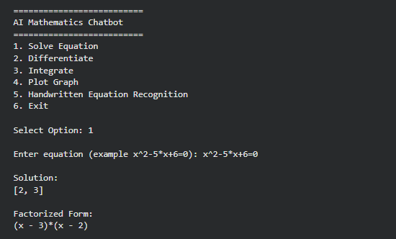

Test Case 2
Input:
Differentiate x^2-5*x+6
Output:
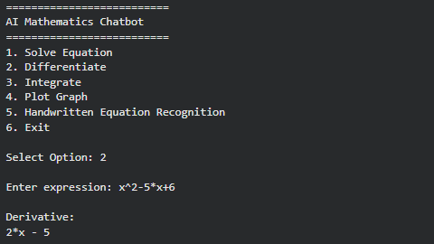

Test Case 3
Input:
Integrate x^2-5*x+6
Output:
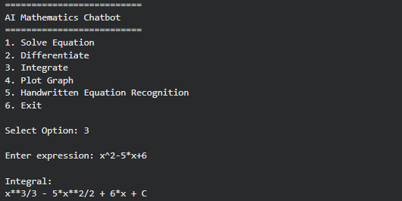
Test Case 4
Input: Graph x^2-5*x+6
Output:
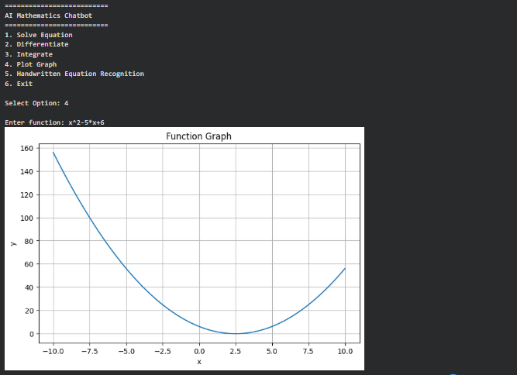

Test Case 5
Input: Handwritten image of equation
Output:
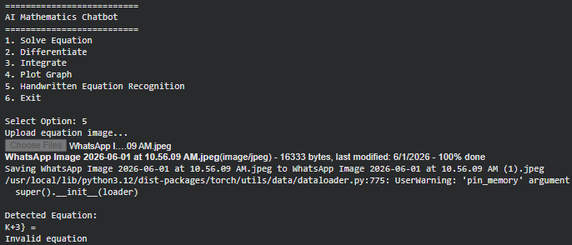

6.Advantages
- User-friendly interface
- Supports symbolic mathematics
- Recognizes handwritten equations
- Generates mathematical graphs
- Enhances student learning
- Low computational cost
- Easy deployment on cloud platforms

7.Limitations
- OCR accuracy depends on handwriting quality.
- Complex mathematical notation may not always be recognized correctly.
- Currently supports only single-variable mathematics.
- Does not yet support advanced theorem proving.

8.Future Enhancements
Future versions may include:
- Deep Learning-based OCR
- Voice interaction
- Multi-language support
- Real-time camera equation scanning
- Matrix operations
- Differential equation solving
- AI-generated mathematical explanations
- Mobile application deployment
- Large Language Model integration

Conclusion
This project successfully demonstrates the integration of Artificial Intelligence, Natural Language Processing, Optical Character Recognition, Symbolic Computation, and Graph Visualization into a unified mathematical assistant. The chatbot is capable of understanding mathematical queries, solving symbolic equations, recognizing handwritten expressions, and generating visual representations of functions. The proposed system provides an effective educational tool that enhances mathematical learning and serves as a strong foundation for future intelligent tutoring systems.

